EXPERIMENT – 20.

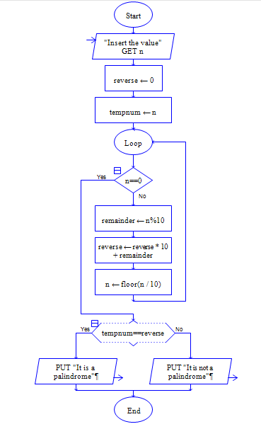

Output:

